Table 1: Patient’s demographic
 | Total (n=6)
Characteristics  Age, years (mean ± SD)  Gender (n, %)  Body weight, kg (mean ± SD)  APACHE IV score (mean ± SD)  SOFA score (mean ± SD)  MAP (median, IQR)  Urea (median, IQR)  Serum creatinine (median, IQR)  Albumin (median, IQR)  WBC (median, IQR) | 50.0±15.8  Female, Male  70.0±10.9  23.8±3.3  11.7±2.7  76.5 (69.0-91.5)  22.8 (20.5-26.9)  337.5 (226.5-440.3)  27.5 (25.5-29.5)  23.7 (18.0-36.0)
Vancomycin
Dosing (mg/kg/day) (mean ± SD) | 22.6±4.3
CRRT
CVVH (n)(%) | 6 (100)
Blood flow, ml/min  Effluent flow rate, ml/kg/H | 150-200  29.3±5.5
Fluid replacement | 2000 ml/h (pre and postdilution, ratio 1:1)
SD, standard deviation; APACHE, acute physiologic; SOFA, sequential organ failure assessment; MAP, mean arterial pressure; WBC, white blood cell; CRRT, continuous renal replacement therapy; CVVH, continuous veno-venous haemofiltration

Table 2: Vancomycin PK parameters in critically ill patients receiving CRRT
PK parameters | Total (n=6)
Non-compartmental analysis  Total clearance, CL_{total} (L/h)  Volume of distribution, Vd (L)  AUC₀₋₂₄ (mg.h/L)  Minimum concentration (C_{min})  Maximum concentration (C_{max})  T_{max} | 1.3 (1.0-1.8)  35.9 (31.7-44.6)  399.6 (374.3-515.6)  11.9 (10.9-15.1)  31.1 (30.5-32.8)  1.8±0.3
Population PK analysis |  | Coefficient of variation (%CV)
Vd of central compartment (Vc)  Population clearance (CLc)  Kcp  Kpc | 25.3±5.1  1.8±0.8  8.8±12.1  1.0±0.3 | 46.0  37.3  33.1  64.0
Kcp, rate constant for vancomycin distribution from central to peripheral compartment; Kpc, rate constant for vancomycin distribution from peripheral to central compartment; SD, standard deviation; APACHE, acute physiologic; SOFA, sequential organ failure assessment; MAP, mean arterial pressure; WBC, white blood cell; CRRT, continuous renal replacement therapy; CVVH, continuous veno-venous haemofiltration

Figure 1: Vancomycin concentration-time profile of enrolled patients (n=6)
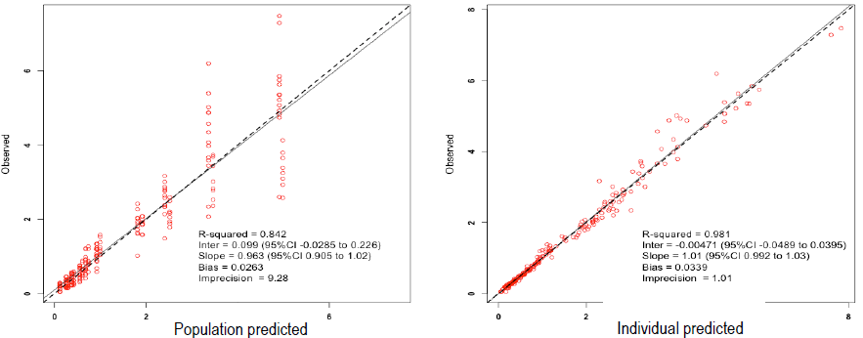

Figure 2: Diagnostic plot for the final population PK covariate model: population (left) and
individual-predicted (right) vancomycin concentration

Figure 3: The observed correlation between minimum concentration (C_{min}) and the 24-h area under the curve (AUC₀₋₂₄)

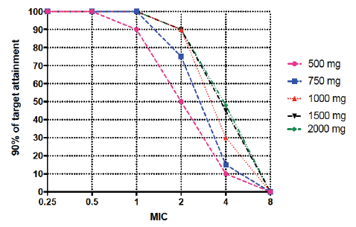

Figure 4: Probability of target attainment for different dosing regimens using Monte Carlo simulation (n=1000)

